RECORDED ARTISTS ACTORS PERFORMERS CLG

Minutes of the Annual General Meeting/ General Assembly of the above named Company held Remotely to the members from the offices of Recorded Artists Actors Performers CLG at RAAP House , 15 Carysfort Avenue, Blackrock Co. Dublin, on Monday 16th November 2020 at 11a.m.

Chairperson: Paddy Cole was appointed Chairperson of the meeting.

Also physically in attendance at the offices of RAAP along with the Chairperson were Andrew Basquille, Colman Clinch and Éanna Casey, the full board were linked in remotely and a further attendance of 27 members registered and participated remotely.

Quorum: The Chairperson noted that due notice had been given and a duly
constituted quorum was present and that the meeting had been convened in accordance with the Articles of Association.

The Notice calling the meeting was taken as read.

The Auditor’s Report on the Financial Statements for the year ended 31 December 2019 was
read.

The Directors’ Report on the Financial Statements for the same period was taken as read.

The Directors’ Report and Financial Statements for the year ended 31 December 2019 were
submitted to the meeting and the following resolutions were passed unanimously:

“That the Directors’ Report and Financial Statements for the year ended 31 December
2019, and as now submitted to this meeting, be and they are hereby approved and
adopted.”

“That the Directors be and they are hereby authorised to fix the remuneration of the
auditors.”

Chairperson Paddy Cole outlined the recent developments in the current dispute with PPI, he outlined two crucial rulings from the High Court and European Court of Justice, a ruling from the High Court stating that RAAP and not PPI have the right to manage the administration of it’s members and it’s affiliates and from the European Court of Justice that the practice by PPI of discriminating as between Performers on recordings is illegal.

The European Court of Justice ruling will ensure that the share as between Performers and Producers will be a 50-50 split of revenues collected from the communication to the public.

The E.C.J ruling will be put back before the Irish courts on 11th December for the form of Orders to be given.

The next step from RAAP will be to look to PPI to repay monies they have withheld from Performers,

Once all the outstanding issues with PPI have been fully resolved RAAP plan to review all our Administration costs and funding both on our Domestic and Foreign income.

The Chairperson noted that 2020 had been a very challenging year for all Performers and indeed the whole entertainment industry and that 2021 would also be very tough, the income generated from Public Performance from bars, restaurants, night clubs has been devastated worldwide and the recovery when it comes will be slow.

The floor was opened to the members for questions and clarifications, one member wanted to know if we were seeking damages, legal advisor Linda Scales replied that we were looking at that.

A number of members stated that they preferred the remote meeting and would the board consider using both facilities the in-person as well as participation remotely, the Chairperson said that the board would consider that request for future AGM’s .

There being no further business the Chairperson thanked all the members in attendance and wished them and indeed all RAAP members and their families a safe and healthy year ahead, the meeting was closed.

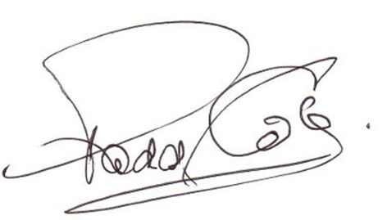

Signed: Date : 16th November 2020
Chairperson

